Q1: DHCP uses several messages such as DHCPREQUEST, DHCPOFFER, DHCPACK, , and DHCPDISCOVER. Find the purpose of these messages.

Q2:What is a DHCP lease?

Q3: Refer to the exhibit. Which rule does the DHCP server use when there is an IP address conflict?

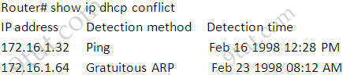

Q4: Determine which of the following is an FQDN and which is a PQDN.

a. xxx

b. xxx.yyy.

c. xxx.yyy.net

d. zzz.yyy.xxx.edu.

e. mil.

f. edu.

g. xxx.yyy.net

h. zzz.yyy.xxx.edu

Q5: If a DNS domain name is *voyager.fhda.edu,* how many labels are involved here?

How many levels of hierarchy?

Q6: Is a PQDN necessarily shorter than the corresponding FQDN?

Q7: A domain name is *hello. customer. info.* Is this a generic domain or a country domain?

Q8: How does caching increase the efficiency of name resolution?

Q9: What is the purpose of the inverse domain?